Night Lamp

Description:
The Table Night Lamp project is a simple electrical circuit designed to provide soft illumination for use on a table or bedside.
In this project, an LED acts as the light source, a switch is used to manually control the lamp, and a coin cell battery provides power.
This project helps beginners understand basic circuit connections, switching operations, and LED control.

Block Diagram:
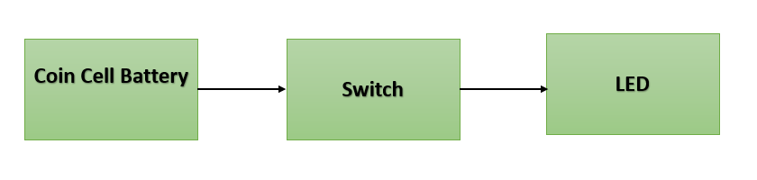

Pinout / Circuit Connection:
Coin Cell Battery (+) → Switch
Switch → LED Anode (+)
LED Cathode (–) → Coin Cell Battery (–)
Power Supply: Coin Cell Battery (3V) using holder

Components Required:
LED
Switch
Coin Cell Battery (with holder)
Wires

Working Principle:
The Table Night Lamp works on the principle of a closed electrical circuit.
When the switch is turned ON, the circuit is completed, allowing current to flow from the coin cell battery to the LED.
The LED converts electrical energy into light energy, providing illumination.
When the switch is turned OFF, the circuit breaks and the LED turn OFF.

Operation (Step-by-Step):
• Connect the LED, switch, and coin cell battery as per the circuit diagram.
• Place the coin cell into the holder.
• Turn ON the switch.
• The LED glows, acting as a night lamp.
• Turn OFF the switch to stop illumination.

Conclusion: (Predefined/self-written)
The Table Night Lamp project demonstrates a basic lighting system using simple electronic components.
It helps students understand battery operation, LED polarity, and manual switching control.
This project is ideal for beginners and can be extended by adding multiple LEDs or decorative enclosures.

For Your References:
[1] Components101, “Light Emitting Diode (LED),” Components101.com. [Online]. Available: https://components101.com/diodes/led-light-emitting-diode. [Accessed: Jan. 15, 2026].
[2] All About Circuits, “Basic Electrical Circuits,” AllAboutCircuits.com. [Online]. Available: https://www.allaboutcircuits.com/textbook/direct-current/chpt-1/what-is-a-circuit/. [Accessed: Jan. 15, 2026].

